Project 1 Final Report
Savannah Gamage
CMPSC 445: Applied Machine Learning in Data Science
Dr. Janghoon Yang
March 17, 2026

Description
The goal of this project was to develop a regression-based model to identify the root causes to global temperature change. This involved collecting environmental data from multiple sources and merging the data into a large dataset. Afterwards the data was preprocessed to ensure all values were correct and understandable with the other datasets. A linear regression model was then trained on this data to determine what variables caused the most temperature abnormalities. Features were then ranked to see which were the most influential on temperature along with visualizations showing the relationship between certain features and temperature.
Data Collection
The datasets that were used were from three organizations: NOAA Global Monitoring Laboratory, NASA GISS Surface Temperature Analysis, and Our World in Data (OWID). The data from the NOAA provided monthly averages of CO2 concentrations for each month from March 1958 to February 2026. The dataset also had other information such as the standard deviation of days which were not needed for the final dataset. Since the only values that were needed were Year, Month, and average CO2, the dataset was copied and filtered to have only those features. The NASA GISS dataset had global data on changes in temperature from January 1880 to February 2026. This dataset was formatted differently, as it had the months on the x-axis and the years on the y-axis. This means that the year and month are on separate rows. To prepare the data for merging, the dataset had to be separated and put back together so that year and month are on one row. Finally, the Our World in Data dataset had CO2 concentrations for every country from 1750 to 2024, including a section for global data records. The OWID data was filtered for only the features needed: Year, Global Data, and CO2_emissions.
Data Preprocessing
After the data was collected, it was then preprocessed to provide consistency between the datasets. For each dataset, there were values that were incomplete or completely missing from the data that was filtered. Since those rows could not be used, they were dropped. Then, the datapoints gathered from the 3 datasets were merged together and sorted by Year and Month to better search through the data. Because the datasets do not have the same features aside from date, certain information needed for the project may not have spread through all the rows during the merge. Therefore, after the final dataset was sorted, rows were dropped that did not have information for CO2 and Temperature. This leaves the merged dataset with 5 features: Year, Month, CO2, Temp, and CO2_emissions. With a small number of features, the linear model will be underfitted, causing poor performance. To prevent this, feature engineering will be used to create new features based on ones already in the dataset. A feature called “time_index” was implemented to represent the passing months between rows. Other features created were a percent change of CO2 from previous months (CO2_growth), a yearly moving average of CO2 and temperature (C02_ma12 and Temp_ma12), and the values of CO2 from previous months (C02_lag1) or years (C02_lag12). Sine and Cosine cycles were also included to represent seasonal patterns between the months (Month_sin and Month_cos). After feature engineering, the dataset had 14 features which was enough for the data to be properly fitted.
Example of Rows After Preprocessing:
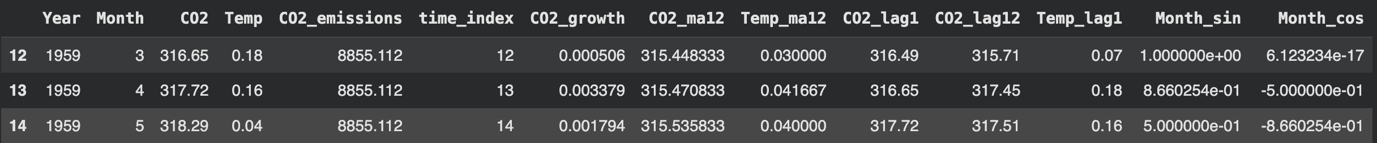
Model Development
The final dataset was split to be used on a linear regression model with 70% of the data used training data and the other 30% as test data. The target variable was Temperature with the inputs being the rest of the engineered features, excluding Year, Month, and Temperature. The data values were then standardized to prevent large numbers from overtaking the model using StandardScaler. Finally, the split training data was fitted to a linear regression model using LinearRegression from the sklearn library.
Root Cause Identification via Feature Ranking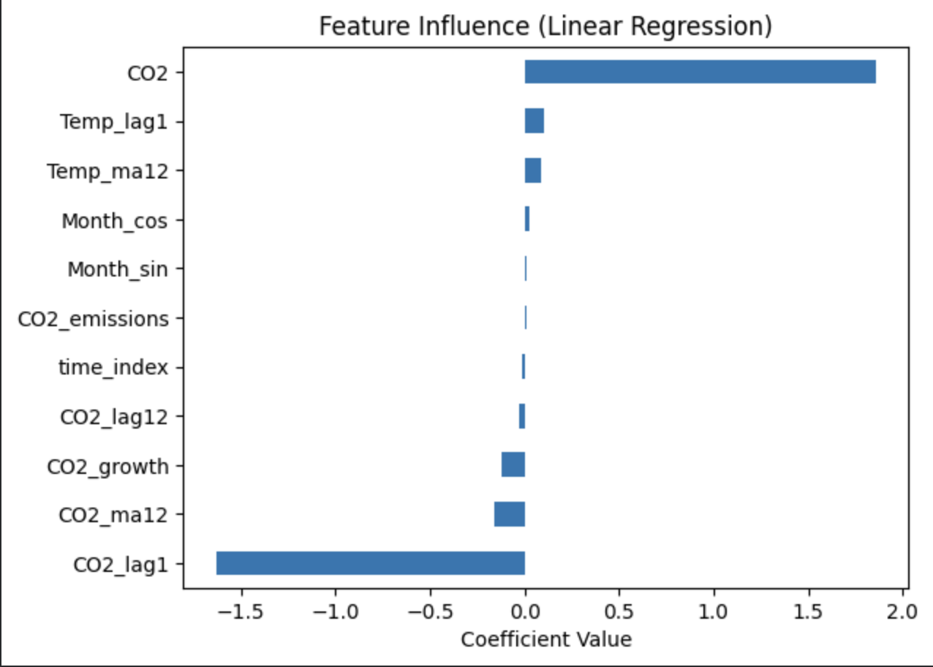
Once trained, the model’s features were ranked based off regression coefficients. The bar plot showed that CO2 concentrations were highly associated with temperature change. Human made contributions like CO2_emissions received an almost 0 coefficient value. This is because the feature was not as heavily associated with temperature changes as the CO2 was more associated with temperature anomalies than CO2_emissions. Because the model includes features that are very similar to the CO2 data, i.e. CO2_lag1 and CO2_ma12, this creates multicollinearity, making it a negative coefficient value. Overall, CO2 and features based on CO2 data were largely associated with changes in temperature.
Visualization
4 graphs were made from the data, visualizing the relationships between certain features and the temperature change. The first graph was a line graph showing CO2 vs Temperature over time. 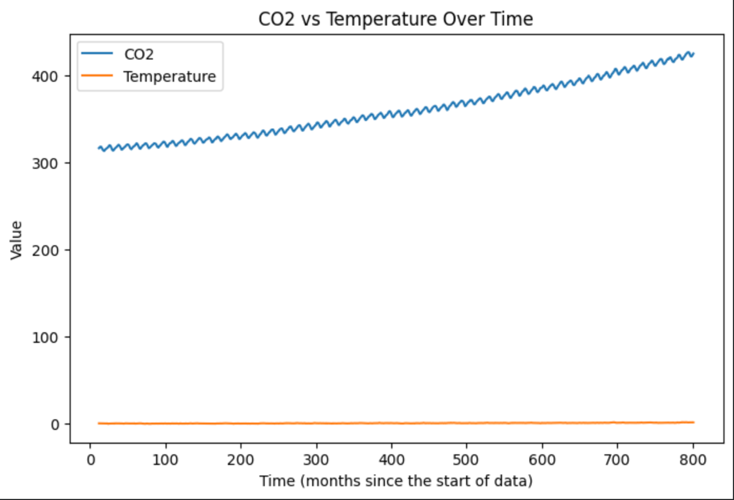
This graph does not accurately show how CO2 values affect temperature due to the CO2 values being much higher and fluctuating than the changes in temperature. This leads to the temperature line looking like a straight line while CO2 has fluctuations as it increases.
The three other graphs were scatter plots comparing temperature vs the top 3 important features. Importance was calculated using the absolute value of the coefficient values to account for multicollinearity. This led to the top 3 important features being CO2, CO2_lag1, and CO2_ma12. Because they are based on the same data, the scatter plots look nearly identical to one another.
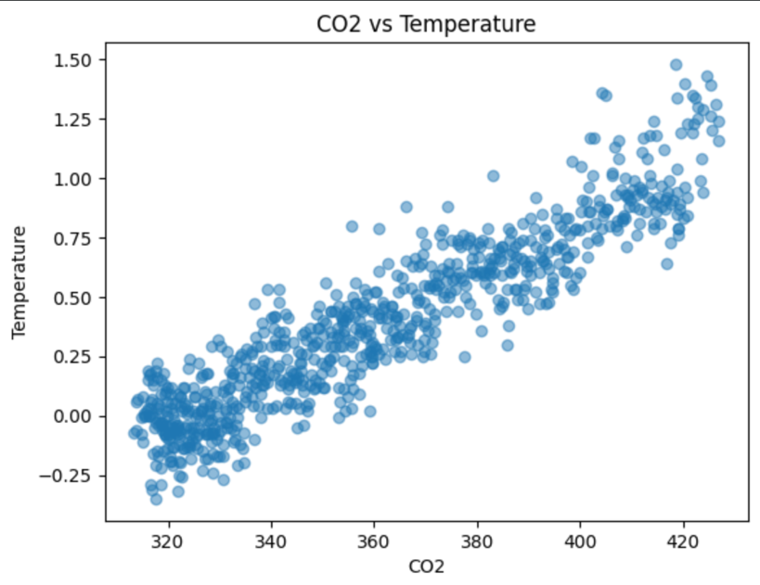
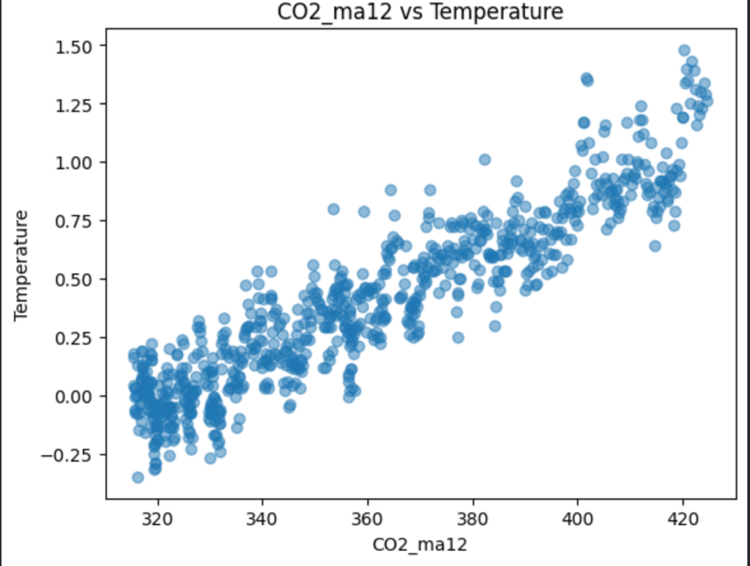
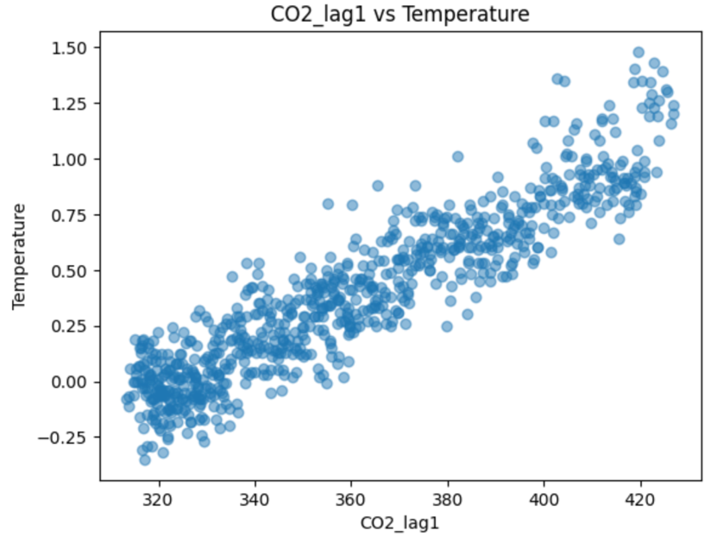
Discussion and Conclusion
All three scatter plots show a linear relationship between the features and temperature. This means that the concentrations of CO2 from the past and present day contribute to influencing temperature abnormalities. These results are consistent with what climate scientists conclude about CO2 in our environment. Scientists agree that concentrations of CO2 are the main cause of global warming today which coincides with the results of the regression model.
The biggest challenge in this project was preprocessing and merging the data together. The NOAA and NASA GISS datasets were monthly datasets while OWID data was annually. The way NASA GISS was formatted created problems as months were on the x-axis and year was on the y-axis. To fix this I had to manipulate the data so that each row represented the month and year along with its information, which left me with over a thousand rows of data. However, when I had to merge the datasets together, I had to focus on Year due to the OWID data not having months, leading to a lot of rows being lost. After filtering out the data points that did not have a value for CO2 or Temperature, I was left with over 800 data points in the dataset. After feature engineering, I was left with even less.
Although the linear regression model does identify the relationship between CO2 and temperature abnormalities, that does not prove that it is the sole cause of it. Other factors that were not included like solar irradiance and volcanic activity could also lead to temperature changes. This is one of the main issues with linear regression models as they do not paint a whole picture on the subject. There are also ethical concerns when it comes to data reliability. Scientist might include their own bias in official data to overexaggerate the problem of human driven factors.

Overall, the linear regression model proves CO2 concentration is a strong cause of temperature change.

AI Usage Statement
AI was used to debug code for any mistakes. All processes of data collection, feature engineering, model training, and testing were done unassisted to ensure consistency and compliance with project instructions.

